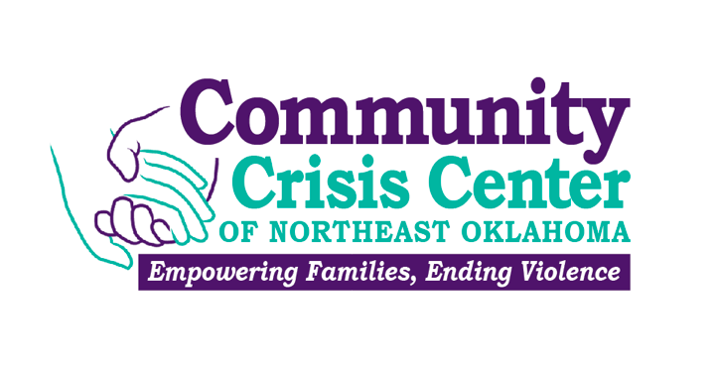

Domestic Violence Advocate Intern

Up to 40 hours per week / Varied schedule / Unpaid credit only

Agency Description:

Community Crisis Center is a small, fast-paced crisis and prevention agency that serves victims of domestic violence, sexual assault and stalking in NE Oklahoma. The agency’s three county service area hosts walk-in community based advocacy services in Jay, Grove, Vinita, and Miami as well as an 18-bed shelter in Ottawa County. Close to 500 families a year are provided no-cost shelter and access to counseling, housing, legal, and life skills support to help transition away from violence and abuse. Detailed information about the agency can be found at www.getmeout.org.

Internship Description:

The intern who fills this position should expect to learn all aspects of domestic violence, sexual assault and stalking dynamics, current trends in service delivery to assist victims, trauma informed approaches to working with victims of diverse populations, and coordinated interagency strategies to improve victim safety. The intern will work with victims in shelter, court, medical, and law enforcement environments. Work will be based out of Miami, Oklahoma.

It is essential applicants have strong communication skills, strict understanding of and adherence to confidentiality, and demonstrate acceptance of diverse populations.

Responsibilities:

- Complete training and shadowing required for internship participation

- Perform tasks at the Shelter

- Answer the crisis telephone line at the Shelter and provide crisis intervention. Assessing needs and make informed referrals to other community resources.

- Screen incoming clients and see to their immediate comfort and needs. This procedure entails talking with new clients to determine eligibility; completing necessary admission forms, completing service sheets and other paperwork.

- Responsible for overseeing shelter operations during shift. Inspect shelter at regular intervals and see to client needs.

- Responsible for documenting client services according to CCC policy

- Required to attend CCC new hire orientation, shelter staff meetings, full staff meetings, and in-service training. Must adhere to continuing education requirements.

- Must strictly uphold confidentiality standards

- Assist the Shelter Administrator with assessing shelter maintenance needs

- Maintain staff chores, including processing donations

- Other duties as assigned

Philosophy of Work:

- Responsible for creating an inclusive environment and behaving in a way that ensures that clients and employees feel: embraced, no matter what their cultural orientations are, respected and valued, engaged and connected to the community, and safe from abuse and harassment.

- Provide services in a trauma informed manner.

- Cooperative team spirit, strong personal boundaries, supportive attitude, and desire to help people.

Qualifications:

- Good listening and problem solving skills
- Understanding and sensitivity toward the issues of domestic violence, sexual assault, stalking, and chemical dependency
- Ability to work with others in a collaborative decision-making process
- Ability to manage time and work effectively in stressful situations
- Must pass a national level criminal background check

Benefits:

- Practical experience working directly with victims of intimate partner violence
- Shadowing, mentoring, and training opportunities with skilled trauma informed professionals
- Opportunity to participate in community networking meetings and events
- Flexible 24-hour based schedule for student

